- Purpose

This procedure defines the proper use of the Hayssen Bagging machine. The steps of operation include taking the preprinted film, folding it, sealing it, filling it, and discharging the filled bag onto a conveyor belt for boxing to ship.

- Scope

This procedure applies to all manufacturing workers.

- Responsibility

Lead Operator and/or Process Operator

- Safety Considerations

All safety glasses and appropriate safety apparel is to be worn at all times.

Safety is a condition of employment. Employees are not authorized to work in an unsafe manner and are prohibited from harming the environment of the facility or community.

- Materials/Equipment

N/A

- Procedure

This procedure covers operation of the Hayssen Bagging machine. The bagger takes the preprinted film, folds it, seals it, fills it, and discharges the filled bag onto a conveyor.

Starting Bagger

- Turn on power to bagger (if not already on)
- From the Operations tab, press the ‘Single Cycle’ button, until an empty bag with air tight seals is discharged.
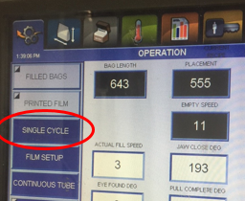

- Ensure the conveyor is on
- Ensure the gate valve on top of the scale is open
- Press the start button

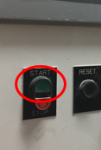

Bagger Operation

- Operator to check bag weights every hour.
- Change film when needed.
- Check once per pallet for leaking bags and bad seals.
- Make necessary interventions, or call maintenance for help.

Stopping Bagger

- Shut off feed to hopper
- Run bagger until empty
- Press the stop button

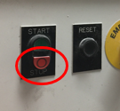

Loading film

- Cut film feed from existing roll
- Remove old film roll
- Install new film roll
- Tape old film feed to new film roll
- Allow new film to feed through machine
- Ensure the bagger is producing air tight bags before proceeding to filling

- Reference Documents

N/A

- Change Information

- Changed document owner
- Added ‘Hayssen’ clarification
- Added Process Operator, removed Salt Operator
- Altered steps to match new Hayssen bagger controls

